Construction of 2D/0D/2D face-to-face contact g-C₃N₄@Au@Bi₄Ti₃O₁₂ heterojunction photocatalysts for promising dye degradation
Huajing Gao ¹, Xinxin Zhao ¹, Chunni Wang ¹, Haimin Zhang ¹, Jiafu Chen ², Shifa Wang ³ and Hua Yang ^{1,}*
¹ State Key Laboratory of Advanced Processing and Recycling of Non-ferrous Metals, Lanzhou University of Technology, Lanzhou 730050, China; ghj2011@yeah.net (H.G), zhaoxinxin7520@163.com (X.Z.), zh_haimin@tom.com (H.Z.), hyang@lut.edu.cn (H.Y)
² Ministry of Education Key Laboratory of Testing Technology for Manufacturing Process, Southwest University of Science and Technology, Mianyang 621010, China; flyingbanana@yeah.net (J.C.)
³ School of Electronic and Information Engineering, Chongqing Three Gorges University, Chongqing, Wanzhou 404000, China; 20180011@sanxiau.edu.cn (S.W.)
* Correspondence: hyang@lut.edu.cn; Tel.: +86-931-2973783

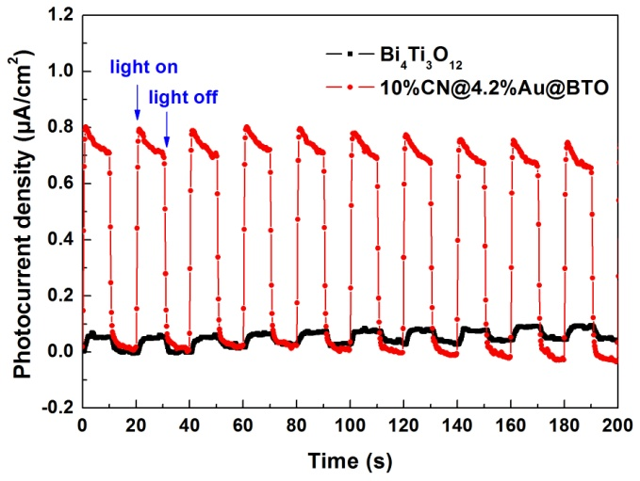
Fig. S1. Transient photocurrent response curves of Bi₄Ti₃O₁₂ and the 10%CN@4.2%Au@BTO composite.
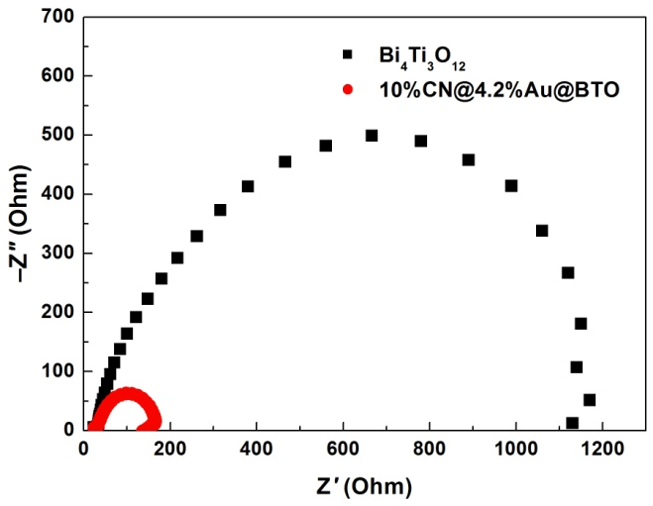
Fig. S2. Photoelectrochemical impedance spectroscopy (EIS) spectra of Bi₄Ti₃O₁₂ and the 10%CN@4.2%Au@BTO composite.

